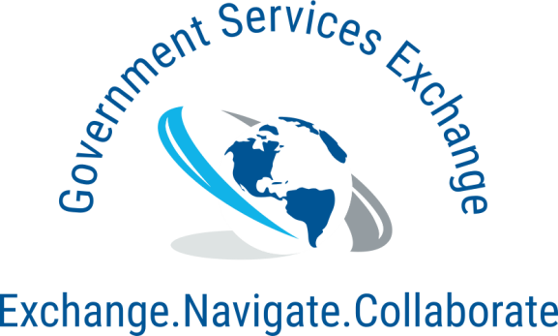

* SAM Registration Assistance
* DLA/DIBBS Registration/Assistance
* State/City/County Registration
* WOSB/EDWOSB/WBE Certification
* VOSB/SDVOSB Certification
* 8(a) Business Development Program
* MBE/DBE Certification
* Proposal Writing
* GSA/FSS Schedule Contract
  + Application Assistance
  + Modifications
  + Uploads
  + Consulting
* Open Market Consulting (GSE Gov Expert)
  + Bidding
  + Marketing
  + Subcontracting
  + Market Analysis
* Capabilities Statement
* Government Landing Page Website
* Email Marketing (B2G or B2B)

**CONTACT US:**  
Eric Coleman, Senior Procurement Specialist  
**P:** (800) 414-3263 **E:** [eric@governmentservicesexchange.com](mailto:eric@governmentservicesexchange.com)   
4701 Sangamore Rd Suite 100N  
Bethesda, MD 20816-2558

**[www.GovExpert.com](http://www.GovExpert.com)**

* Bid Opportunities – Federal, City, State and Municipal Government
* 30,000 Federal Procurement Buyers Contact info
* City, State and County Procurement Buyers Contact info
* Expiring Contracts through 2022
* Award History dating back to 2001
* Contact info and award history for every SAM registered business
* Subcontractor-prime relationship history
* Top 100 prime contractors by NAICS
* Agency Forecasting
* Machine Shop Opportunities
* DLA NSN Opportunities along with drawings, forecasting and prime contractors
* And much more!

**Government Services Exchange** has a combined 35+ years’ worth of experience in the fields of Government Contracting and Government Compliance. We are proud to employ a diverse group of Government Contract Consultants, Marketing strategists and Procurement specialists to further enhance the American and U.S. Governments fair and equitable acquisition. Our goal is to, for businesses, take all the guess work out of Government Contracting and allow the business to focus on what they do best, while we worry about doing business with the Government for you.

* We don’t just offer certification/ registration/ application assistance, we will also apply the services we have provided and assist you in best utilizing your cert/reg/app.
* Over 25 years combined industry experience.

**Core Competencies**

**Differentiators**

**GSE Gov Expert**

**P:** (800) 414-3263 **W:** [www.governmentservicesexchange.com](http://www.governmentservicesexchange.com)   
4701 Sangamore Rd Suite 100N Bethesda, MD 20816-2558

**Government Services Exchange**We Make Government Contracting Easy

**DUNS: 116699861 CAGE: 86SR0 NAICS: 541611   
SET-ASIDE: Small Business**